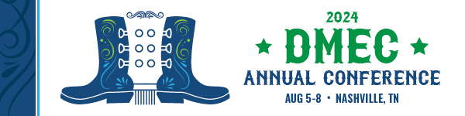

MARKETING TOOLKIT
We are pleased you will be participating in the 2024 DMEC Annual Conference, Aug. 5-8, at the Gaylord Opryland Resort & Convention Center in Nashville, TN. We encourage you to spread the word about your participation through your personal and professional social channels.

With four days of education and extended networking, attendees will have the opportunity to reconnect with peers, build new connections, and gain expert solutions to their most complex absence and disability management challenges. Visit www.dmec.org/annual-conference for additional event details.

Event Links & Tags
We recommend tagging DMEC’s social channels — @DMECAbsenceMgt (Twitter/X), @DMECinc (Facebook), and @Disability Management Employer Coalition (LinkedIn) — and using the hashtag #DMEC2024 when posting about the conference to increase the visibility of your company at the event.

Social Media Post Suggestions
[Company name] is [sponsoring the or exhibiting at the] upcoming 2024 DMEC Annual Conference, Aug. 5-8. Join us in Music City Nashville and register to attend the event. www.dmec.org/annual-conference

Excited to announce [company name] will be [sponsoring the or exhibiting at the] upcoming 2024 DMEC Annual Conference. Join us at the premier event for absence & disability professionals in Nashville and register to attend. www.dmec.org/annual-conference

Looking forward to attending 2024 DMEC Annual Conference, Aug. 5-8, in Nashville! Join [company name] at [booth number]. www.dmec.org/annual-conference

Thrilled [company name] will be participating in the 2024 DMEC Annual Conference. Register to attend the event, Aug. 5-8, in Nashville. www.dmec.org/annual-conference

[Company name] will be [sponsoring the or exhibiting at the] upcoming 2024 DMEC Annual Conference and will [details about special offerings, giveaways and promotions]. Join us at the event. www.dmec.org/annual-conference

Grab a colleague and attend the 2024 DMEC Annual Conference, Aug. 5-8, in Music City Nashville. [Company name] will be there. www.dmec.org/annual-conference

Promotional Images
To demonstrate your conference participation, you can use the images below on social media channels.
Include the images below in your email signature line by copying and pasting it into your signature directly. Once inserted into your signature, right click on the image, click “link,” paste http://www.dmec.org/annual-conference into the “address” field, and click OK.

