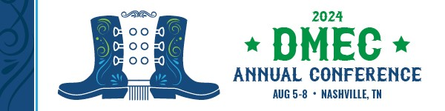
Dear [Supervisor/Decision Maker],
The 2024 DMEC Annual Conference, Aug. 5-8, at the Gaylord Opryland Resort & Convention Center in Nashville, TN, is the premier conference for absence and disability professionals. This conference offers education, networking, and professional development opportunities designed to address current trends and challenges in the industry. I believe my participation is critical to bringing new approaches to our organization, ensuring our programs remain compliant, and furthering my professional development. I would like to request approval to attend.
I will have the opportunity to connect with 700+ professionals, including industry leaders from across the United States and Canada, and gain unique insight and innovative strategies that will help us build integrated, compliant absence and disability programs. The DMEC Solutions Marketplace conference offers a unique opportunity to connect with service, technology, and program providers and evaluate external services that may be of interest to our orgnization. For more information about the conference, visit www.dmec.org/annual-conference.
I plan to attend the following {tracks or sessions] to strengthen my industry knowledge and enhance my professional development: List the tracks or sessions you plan to attend and how they will benefit you, your team, and your organization. _________________________________________________________________________________________________________________________________________________________________________________________________________________________________________________________________________________________________________
I plan to speak with the following exhibitors that could provide effective solutions for our organization: _________________________________________________________________________________________________________________________________________________________________________________________________________________________________________________________________________________________________________
Here are my projected costs for attending the 2024 DMEC Annual Conference:
Registration Fee $XX
Hotel $XX
Airfare $XX
Miscellaneous (meals, transportation, etc.) $XX
Total $XX

This investment will pay off in the effective and compliant solutions I will bring back to our organization. After the conference, I will provide a summary of key takeaways and recommended actions.
I would appreciate your approval of this request and will work to ensure we get the full value out of the conference.
Sincerely,
[Your Name]

